**Advanced chatbot for Real estate**

**Introduction:-**

* **Overview :-**
* The typical customer care chatbot can answer simple questions, such as store locations and hours, directions, and maybe even making appointments. When a question falls outside of the scope of the pre-determined question set, the option is typically to tell the customer the question isn’t valid or offer to speak to a real person.
* In this project, there will be another option. If the customer question is about the operation of a device, the application shall pass the question onto Watson Discovery Service, which has been pre-loaded with the device’s owners manual. So now, instead of “Would you like to speak to a customer representative?” we can return relevant sections of the owners manual to help solve our customers’ problems
* **Purpose :-**
* The purpose of the project is to make the chat with customer in more effective way .This project aim to solve the major customer problem without any human interaction with its power of understanding the language and also the document to provide the detail solution of the customer problem.
* This chatbot will efficiently answer all the query of customer with its smart document understanding ability and guide toward the solution of the problem.

**Literature Survey:-**

* **Existing problem:-**
* The present typical customer care chatbot can answer simple questions, such as store locations and hours, directions, and maybe even making appointments. When a question falls outside of the scope of the pre-determined question set, the option is typically to tell the customer the question isn’t valid or offer to speak to a real person .It can guide through only small set of predefined sentence . The present chatbot cannot understand when the sentence are rearrange or rephrase.
* Many a time this chatbot unable to answer the query of the customer and often required the human interaction to answer the question or guide a customer to the solution.
* **Proposed solution:-**
* In this project we have built a chatbot which use natural language processing that will help to understand the query of a customer in a better way rather than the typical chatbot that can only answer the predefined queries .The natural language processing will understand the type of question it has been asked.
* Another feature of this chatbot is its smart document understanding that will help to understand the long user manual to guide the customer with more query in a detailed manner .The query asked by the customer will be searched in to user manual to provide the detail solution of the problem. This will lead to less human interaction to deal with customer in efficient way.

Theoretical Analysis :-

* Block diagram :-

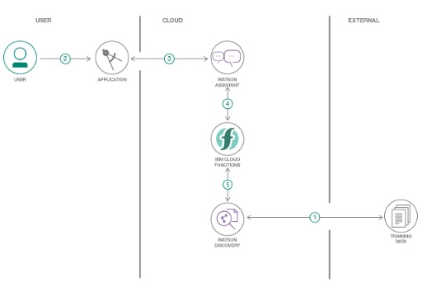

* Software requirements:-
* **Watson assistant**:- Watson Assistant is a conversation AI platform that helps you provide customers fast, straightforward and accurate answers to their questions, across any application, device or channel.
* **Watson discovery:-**Watson Discovery is an award-winning enterprise search and AI search technology that breaks open data silos and retrieves specific answers to your questions while analyzing trends and relationships buried in enterprise data. Watson Discovery applies the latest breakthroughs in machine learning, including natural language processing capabilities, and is easily trained on the language of your domain.
* **Node red:**- Node-RED is a programming tool for wiring together hardware devices, APIs and online services in new and interesting ways .It provides a browser-based editor that makes it easy to wire together flows using the wide range of nodes in the palette that can be deployed to its runtime in a single-click.

**Flowchart:-**

**Result:-**

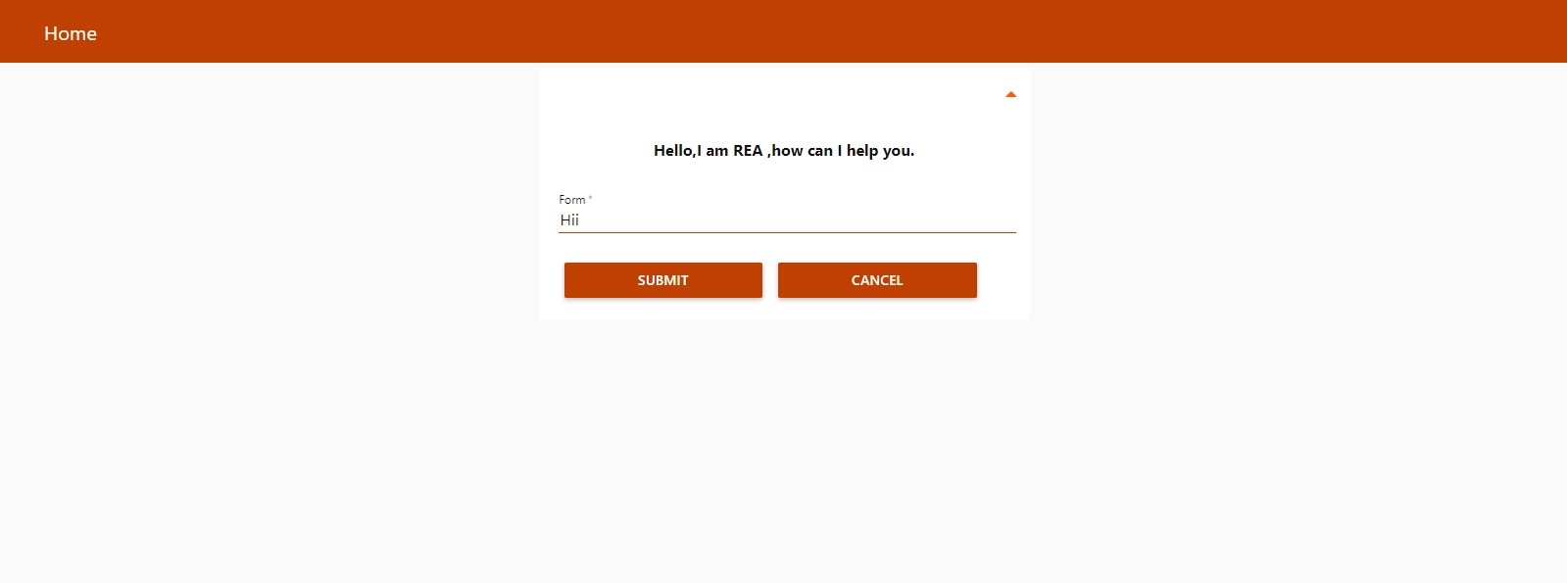

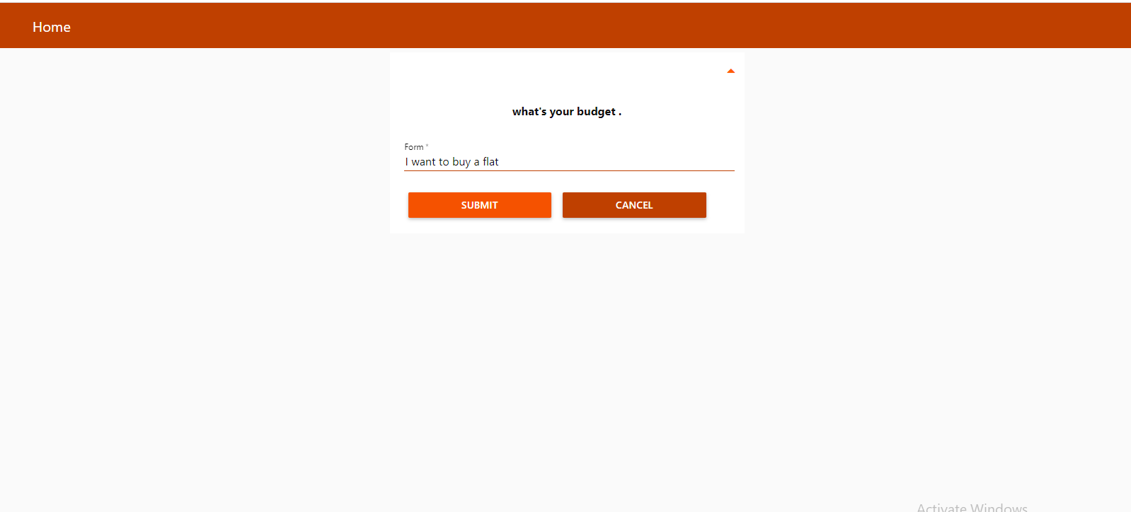

**Applications:-**

* It can be integrated with the website to deal with the customer efficiently and guide customer in an attractive way.
* Automate responses to customer inquiries with greater speed and accuracy using industry-leading natural language understanding (NLU). Achieve lower cost per conversation by continuously training your assistant to understand customer needs.
* A smart document understanding of chatbot will answer the most of the query of customer without any human interaction and in a detailed manner.

**Conclusion:-**

Thus the chatbotwill help you to focus more on a product rather than answering a repetitive query of a customer .This will also help to attract a customer into your service.

If the query is about device functionality it will search on preloaded manual so rather by saying “would you want to talk to customer” it will give a detail guide through a user manual.